**UNIVERSITY OF MUMBAI, MUMBAI**

**A**

**PROJECT REPORT**

**ON**

**“DESIGN AND FABRICATION OF BATTERY**

**POWERED SEGWAY”**

**Submitted in partial fulfilment of the requirement for the degree of**

**Bachelor of Engineering**

**In**

**MECHANICAL ENGINEERING**

**By**

|  |  |
| --- | --- |
| 1. **Sejal Bhargav Bhosle** | **(171071006)** |
| 1. **Amay Bhalchandra Gholpe** | **(171071013)** |
| 1. **Ashwini Ananda Sonavane** | **(171071041)** |

**Under the Guidance of**

**Prof. A. A. MATE**



**Department of Mechanical Engineering**

**A. C. Patil College of Engineering, Kharghar**

**Navi Mumbai, Maharashtra.**

**2020-21**

**A. C. Patil College of Engineering**

**Kharghar, Navi Mumbai-410210**

**CERTIFICATE**

|  |  |
| --- | --- |
| 1. Sejal Bhargav Bhosle | (171071006) |
| 1. Amay Bhalchandra Gholpe | (171071013) |
| 1. Ashwini Ananda Sonavane | (171071041) |
|  |  |

This is to certify that,

Studying in B.E. Mechanical has successfully completed the project entitled

**“DESIGN AND FABRICATION OF BATTERY**

**POWERED SEGWAY”**

Under the guidance of Prof. A.A. Mate during academic year 2020-21. This is a part of partial fulfilment of the requirement for submission of

UNIVERSITY OF MUMBAI,

MUMBAI.

|  |  |
| --- | --- |
|  |  |
|  |  |
| Prof. A. A. Mate  Project Guide | Prof. Dr G. P. Deshmukh  Head of Department |
| Department Of Mechanical Engineering  A.C. Patil College OF Engineering, | Department Of Mechanical Engineering  A.C. Patil College OF Engineering, |
| Kharghar | Kharghar |

**ACKNOWLEGEMENT**

We would like to express our deep and sincere gratitude to our Guide **Prof. A. A. Mate,** Department of Mechanical Engineering, for guiding us to accomplish our project work. It was our privilege and pleasure to work under her able guidance. We are indeed grateful to her for providing helpful suggestion, from time to time. Due to her constant encouragement, we are able to present this part of work.

We express our deep gratitude to **Dr G. P. Deshmukh**, Head of Mechanical Department, for his valuable guidance and constant encouragement. We are very much thankful to Dr V. N. Pawar, Principal, A. C. Patil College of Engineering, Kharghar, for providing all the necessary facilities to carry out project work. Last but not the least we are thankful for our parents and friends for their moral support.

**ABSTRACT**

In the 21st century, transportation has become a major concern. A Segway being compact and reliable is bestsuited for short distance applications in urban areas. It was once a mysterious invention created by Dean Kamen, 2001. The purpose of the project is to fabricate a Personal Transporter (PT).This vehicle is designed to overcome the cost of the actual Segway Vehicle and to provide zero pollution within the campus or industries or residential areas as well.

It should be driven by natural movements; forward and backwards motion should be achieved by leaning forwards and backwards. Turning should be achieved by tilting the handlebar sideways. The Segway is based on the principle of inverted pendulum that will keep an angle of zero degrees with vertical at all times. It is an intelligent vehicle which uses gyroscopic sensors detects the motion of rider, so that he can accelerate, brake or steer the vehicle.

It gives a summary of the work done in the fields of mechanical design, electronics, software design, system characterization and control theory. This wide array of fields necessary for the realization of the project holds the project up as a leading example in the field of mechatronics. Here special focus will be on the modelling of the robotic system and the simulation results of various control methods required for the stabilization of the system.

The conventional seaways available in the market are very costly as they are not available locally. Hence the need to design and fabricate a cost-efficient Segway which could be affordable and the same time be reliable to withstand a rider up to 100kgs. In this project an attempt has been made to design and fabricate a Segway with minimum resources.

**INDEX**

|  |  |  |
| --- | --- | --- |
| **CHAPTER**  **NO.** | **CONTENTS** | **PAGE NO.** |
|  | List of Figures |  |
|  | Nomenclature |  |
| 1 | Introduction | 6 |
| 2 | Literature Review | 8 |
| 3 | Experimental Setup   * Methodology * List of Components * Description of Components * Arduino Codes |  |
| 4 | Future Scope |  |
| 5 | Conclusion |  |
| 6 | References |  |

**INTRODUCTION**

In the present days we are dealing with a problem of increase in number of vehicles with everlasting demand of fuel to run them. If this situation remains with time it would be difficult for us to save our future from increasing pollution and fuel demand. With time the population on earth increases obviously, which cannot be controlled so to fulfil the demands of fuel energy in future world, effective steps should be taken as soon as possible. Our dependence on fuel can be reduced with an alternative such as, use of battery operated vehicles. New technology should be implemented, use of eco-friendly vehicles should be encouraged.

Segway is an electric scooter of future technology. It is often use to transport a user across mid-range distances in urban environments. It has more degrees of freedom than car or bike and is faster than pedestrian. They are more efficient than fuel powered vehicles for shorter distance and time of travelling. An electrical vehicle such as Segway, if widely used in a society would give a helping hand in reducing pollution caused by two wheelers. It would save time and efforts in travelling short distances on barefoot for ages of people.

This project is a step towards design, development and programming of an battery powered vehicle using simple algorithm of control over motors via open source board, sensors and microcontroller. It also aims for study and analysis of stability of an electrical vehicle made using open source software and hardware.

* Segway – name derived from ‘segue’ i.e. smooth transition.
* It is battery powered self-balancing electric vehicle.
* It uses number of gyroscopes to track alignment of the platform in horizontal plane and gives command to controller to run the motors.
* If the rider leans forward the motors runs in the forward direction to adjust the alignment, similarly for backward so the platform remains self-balanced.
* Commands to the HT to go forward or backward by shifting weight on the platform.
* Using gyroscopic + accelerometer-based leveling sensors resulting changes in platform orientations measured to maintain balance.
* It drives its wheels forward or backward as needed to return its pitch to upright.
* The HT responds by adjusting the speeds of the wheels in opposite directions causing the PT to rotate and, if not traveling forward or backward, turn in place.
* At speed, the amount of shift of the handlebar corresponds to the amount of left or right lean required by the rider to balance themselves on the platform during a turn.
* It has electric motors powered by lithium-ion batteries, - charged from household current.
* It balances with the help of dual computers that run proprietary software, two tilt sensors, and five gyroscopic sensors
* Do not have mechanical brakes!!

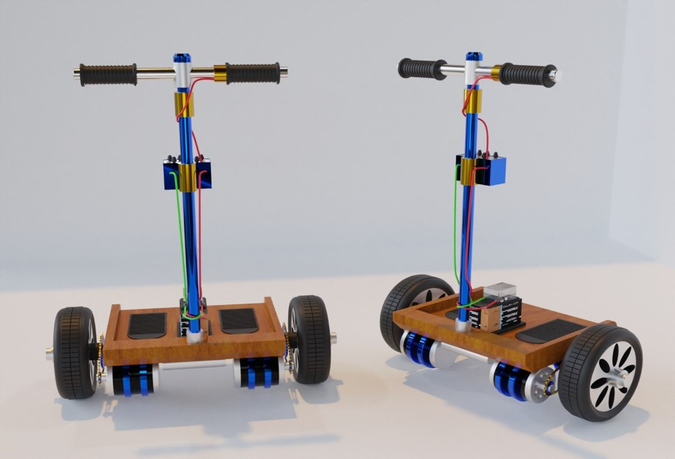

Figure 1- 3D Representation of model

**LITERATURE REVIEW**

[1] PERSONAL TRANSPORTER A PROJECT REPORT Submitted by MEKA SRI SAI KARTHEEK [Reg No: 1021110074] P AVINASH VARMA [Reg No: 1021110540] S.R.M. Nagar, Kattankulathur, Kancheepuram District APRIL 2015.

In this paper, we have noted that they designed and analysed three different models of 2 wheeled vehicles, using different electronics such as gyroscope, accelerometer, etc. and determined whether which model is suited considering their requirements and goals for the project. They have efficiently used analysis methods like SWOT Analysis, Software Simulation and Mathematical Analysis for finding their ideal design. We look forward for including such methods for designing our own model.

[2] MUHAMMAD HARRIS KHAN, MEHAK CHAUDHRY, TAIMOOR TARIQ

In this paper the Segway is designed and fabricated. This paper includes design of a fully functional self-balancing vehicle which is capable of bearing the general human load using the principles of dynamic stability. It uses a BLDC motor controller and needs a control system which is to be implemented for stabilization.500W motor is used for driving and the BLDC controller is designed for the requirements needed. Mathematical modelling of the system is done and PID controller is designed using Root locus for analysis and is implemented on the Segway. The BLDC Motor Controller used in Segway controls the speed and direction of the BLDC motors, like an H-shaped Bridge which controls the rushed DC motor. This controller is capable of doing instantaneous switching of direction depending on the direction of tilting of the Segway. The BLDC controller uses logic gates and a micro controller (for reducing the size of the circuit) and the transfer function is calculated manually and impulse response is also noted down and checked.

[3] DESIGN AND FABRICATION OF SELF BALANCING TWO WHEELER, Pravin Kumar Singh, Abhishek Jaswal, Saurabh Chand, Ali Abdullah, Rishi Chakraborty, UG Scholar Department of Mechanical and Automation Engineering Amity University, Lucknow, India

They created a minimalistic design with simple components so as to reduce the cost of the vehicle to a greater extent as the same time not compromising its actual basic functions. They have included DPDT Switches for mobility (turning, accelerating) thus making their design quite simple and least expensive at the same time making it more light weight.

[4] DESIGN & DEVELOPMENT OF SEGWAY, Mr. Velaji Hadiya, Mr. Aakash Rai, Mr. Sushant Sharma, Miss. Ashwini More, SIEM Nashik, Maharashtra, India.

The paper specifies ways that we can improve functionality of a 2 wheeled horizontal axis vehicle. They have included Gyroscopes, Accelerometers, Motor Drivers and DC Brushed Motors all controlled by a Single-board microcontroller Arduino Uno. We have kept this paper as the base for our design as we both have certain common design goals and look forward to including more innovative and failsafe ideas.

[5] DESIGN AND FABRICATION OF A COST EFFECTIVE AND RELIABLE SEGWAY, Nishant Kiran Nikam, Dipu Ramkishan Mourya, Chirag Sudhakar Patil, Ninad Vilas Patil, Sangam Rane, Bachelor of Engineering Student, Department of Mechanical Engineering St. John College of Engineering and Management, Palghar(E), Palghar, India

This paper shows using similar components for mobility, steering and acceleration but programming the vehicle in such a way that it commendably reduces its speed to 10km/hr. Such type of programming makes the vehicle slower but more long lasting all together using no fossil fuels, completely powered by electricity at a price of ₨.21,000.

[6] MECHANICAL SEGWAY, Ankit S. Khanzode, Ashish G. Masne, Mohd. Shahzad Gulam Ali, Akshay P. Tale, Kamalkishor G Maniyar.

This project report had quite a unique design. They had excluded any kind of complex programming components such as gyroscopes, accelerometers etc and their main design purpose was to reduce design complexity, make the power source rechargeable by means of charging using adapters as well as using Solar Energy. For these purposes they’ve included a solar panel as well. Accelerating and decelerating are operated using DPDT switches. They also have included a Digital Speedometer which is helpful in many aspects.

[7] M.THOMPSON, J.BEULA JULIETTA MARY.

In this paper, a failsafe Segway is designed and fabricated to overcome the failures ( gyroscope failure ) and toppling down of the existing Segway and cut down the cost of the existing gyroscope by eliminating gyroscope and for moving intra campus. The wheels are guarded from the obstacles in this model and has a platform for the driver. The driving wheels are driven by a throttle and runs at a top speed of 60 kmph. It uses a battery of 48v 40ah.

[8] MUHAMMAD UMAR DRAZ , MOHSIN SHAHEER ALI, MARYAM MAJEED, UMAIR EJAZ, UMER IZHAR

In this paper, the Segway electric vehicle human transporter is designed fabricated. This model of Segway uses only two wheels and uses gyroscope and sensors for balancing. It is mainly designed to work on all types of surfaces and compact design which caters shock absorption. It has a top speed of 13km/hr and a balancing time of less than 2 seconds. It uses the concept of inverted pendulum and the vehicle is dynamically stabilized. Multi directional shock absorbers are used. It uses a high motor of 1000W and 13.2 Nm torque with 83% efficiency. It uses electronics for accelerometers and gyroscopes. It uses PID control drive which is controlled by an electronic controller programmed as per the requirement.

**EXPERIMENTAL SETUP**

1. **METHODOLOGY**

Given below is the proposed methodology for the completion of our project and we’re at 40% completion of our project.

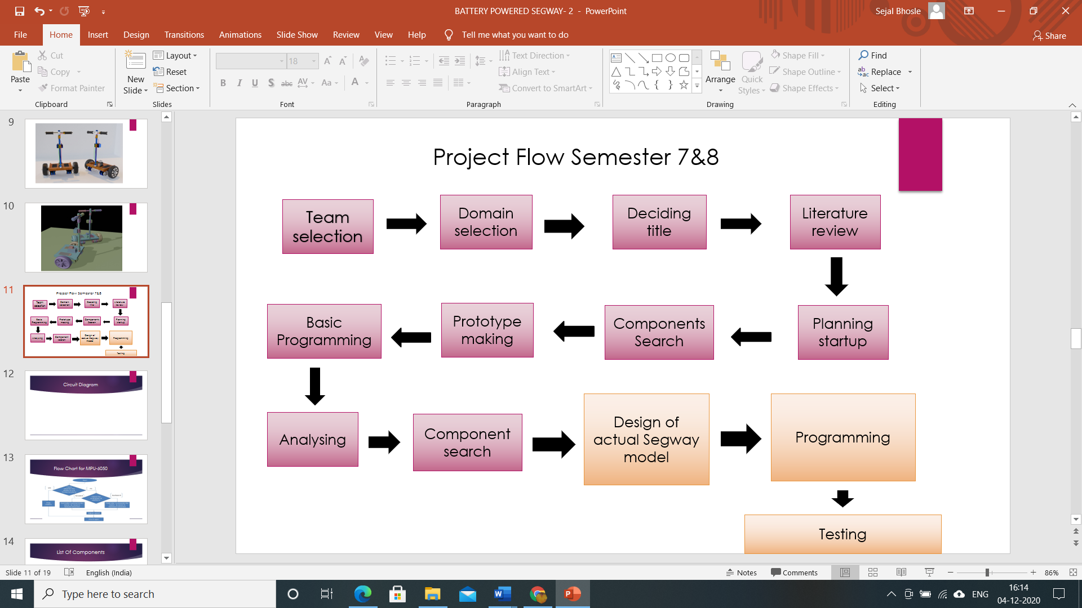

Figure 2- Proposed Methodology

1. **LIST OF COMPONENTS**

* Gyroscope: Accelerometer MPU6050
* L298N Motor Controller
* Arduino UNO microcontroller board
* PMDC motors 250W each
* 12V 12 Ah dry battery
* Wheels
* Adjustable Handle bar
* Switches

1. **DESCRIPTION OF COMPONENTS**
2. ARDUINO UNO MICROCONTROLLER

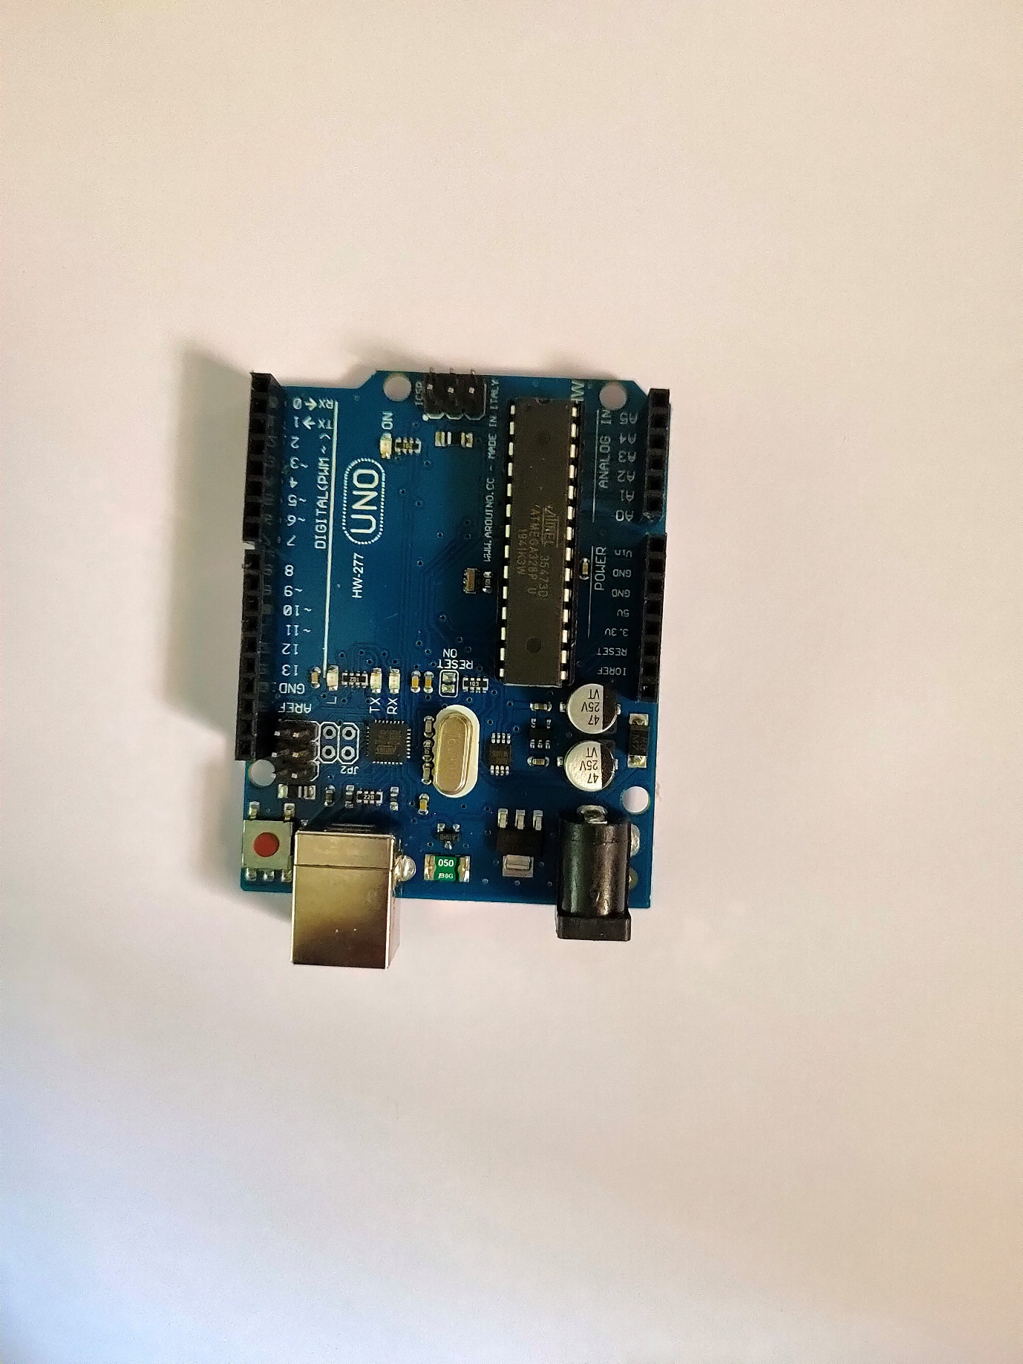

Figure 3- Arduino UNO microcontroller board

The Arduino Uno is an open-source microcontroller board based on the Microchip ATmega328P microcontroller and developed by Arduino.cc. The board is equipped with sets of digital and analog input/output (I/O) pins that may be interfaced to various expansion boards (shields) and other circuits. The board has 14 digital I/O pins (six capable of PWM output), 6 analog I/O pins, and is programmable with the Arduino IDE (Integrated Development Environment), via a type B USB cable. It can be powered by the USB cable or by an external 9-volt battery, though it accepts voltages between 7 and 20 volts. It is similar to the Arduino Nano and Leonardo. The hardware reference design is distributed under a Creative Commons Attribution Share-Alike 2.5 license and is available on the Arduino website. Layout and production files for some versions of the hardware are also available.

The word "uno" means "one" in Italian and was chosen to mark the initial release of Arduino Software. The Uno board is the first in a series of USB-based Arduino boards; it and version 1.0 of the Arduino IDE were the reference versions of Arduino, which have now evolved to newer releases. The ATmega328 on the board comes pre-programmed with a bootloader that allows uploading new code to it without the use of an external hardware programmer.

1. MPU 6050 3 AXIS ACCELEROMETER GYROSCOPE SENSOR

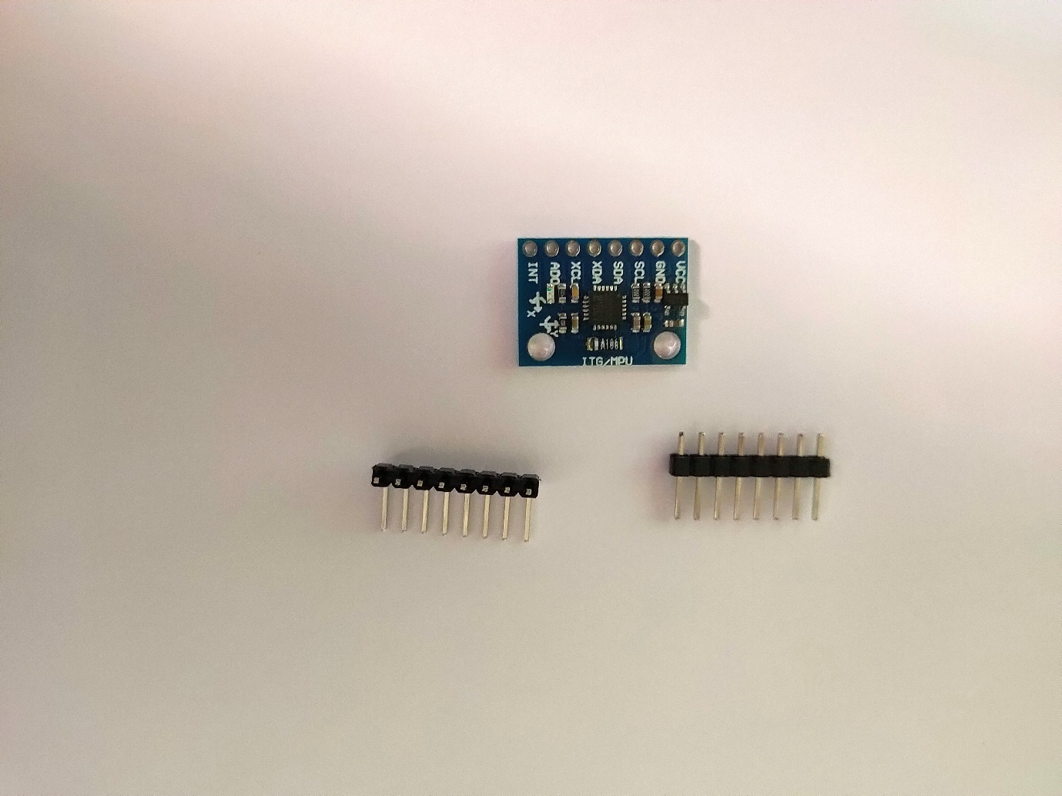

Figure 4 MPU 6050

MPU6050 sensor module is complete 6-axis Motion Tracking Device. It combines 3-axis Gyroscope, 3-axis Accelerometer and Digital Motion Processor all in small package. Also, it has additional feature of on-chip Temperature sensor. It has I2C bus interface to communicate with the microcontrollers.

It has Auxiliary I2C bus to communicate with other sensor devices like 3-axis Magnetometer, Pressure sensor etc.

If 3-axis Magnetometer is connected to auxiliary I2C bus, then MPU6050 can provide complete 9-axis Motion Fusion output.

# 3-Axis Gyroscope

The MPU6050 consist of 3-axis Gyroscope with Micro Electro Mechanical System(MEMS) technology. It is used to detect rotational velocity along the X, Y, Z axes as shown in below figure.

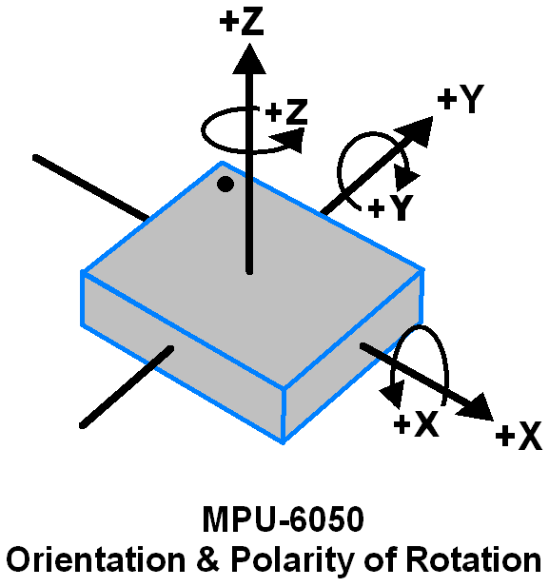

Figure 5

-  When the gyros are rotated about any of the sense axes, the Coriolis Effect causes a vibration that is detected by a MEM inside MPU6050.

- The resulting signal is amplified, demodulated, and filtered to produce a voltage that is proportional to the angular rate.

-  This voltage is digitized using 16-bit ADC to sample each axis.

-  The full-scale range of output are +/- 250, +/- 500, +/- 1000, +/- 2000.

-  It measures the angular velocity along each axis in degree per second unit.

# 3-Axis Accelerometer

The MPU6050 consist 3-axis Accelerometer with Micro Electro Mechanical (MEMs) technology. It used to detect angle of tilt or inclination along the X, Y and Z axes as shown in below figure.

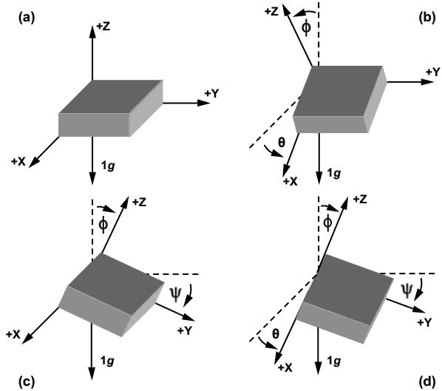

Figure 6

-  Acceleration along the axes deflects the movable mass.

-  This displacement of moving plate (mass) unbalances the differential capacitor which results in sensor output. Output amplitude is proportional to acceleration.

-  16-bit ADC is used to get digitized output.

-  The full-scale range of acceleration are +/- 2g, +/- 4g, +/- 8g, +/- 16g.

-  It measured in g (gravity force) unit.

-  When device placed on flat surface it will measure 0g on X and Y axis and +1g on Z axis.

# DMP (Digital Motion Processor)

The embedded Digital Motion Processor (DMP) is used to compute motion processing algorithms. It takes data from gyroscope, accelerometer and additional 3rd party sensor such as magnetometer and processes the data. It provides motion data like roll, pitch, yaw angles, landscape and portrait sense etc. It minimizes the processes of host in computing motion data. The resulting data can be read from DMP registers.

# On-chip Temperature Sensor

On-chip temperature sensor output is digitized using ADC. The reading from temperature sensor can be read from sensor data register.

# MPU-6050 Module

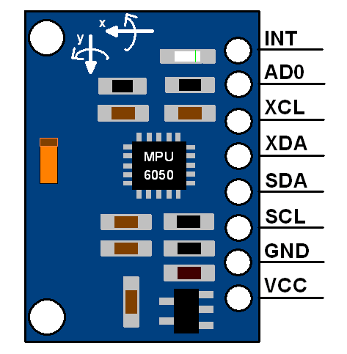

Figure 7

The MPU-6050 module has 8 pins,

**INT:**Interrupt digital output pin.

**AD0:**I2C Slave Address LSB pin. This is 0th bit in 7-bit slave address of device. If connected to VCC then it is read as logic one and slave address changes.

**XCL:**Auxiliary Serial Clock pin. This pin is used to connect other I2C interface enabled sensors SCL pin to MPU-6050.

**XDA:**Auxiliary Serial Data pin. This pin is used to connect other I2C interface enabled sensors SDA pin to MPU-6050.

**SCL:**Serial Clock pin. Connect this pin to microcontrollers SCL pin.

**SDA:**Serial Data pin. Connect this pin to microcontrollers SDA pin.

**GND:** Ground pin. Connect this pin to ground connection.

**VCC:**Power supply pin. Connect this pin to +5V DC supply.

MPU-6050 module has Slave address (When AD0 = 0, i.e. it is not connected to Vcc) as,

**Slave Write address(SLA+W)**: 0xD0

**Slave Read address(SLA+R)**: 0xD1

Calculations:-

Note that gyroscope and accelerometer sensor data of MPU6050 module consists of 16-bit raw data in 2’s complement form.

Temperature sensor data of MPU6050 module consists of 16-bit data (not in 2’s complement form).

Now suppose we have selected,

-  Accelerometer full scale range of +/- 2g with Sensitivity Scale Factor of 16,384 LSB(Count)/g.

-  Gyroscope full scale range of +/- 250 °/s with Sensitivity Scale Factor of 131 LSB (Count)/°/s.

then,

To get sensor raw data, we need to first perform 2’s complement on sensor data of Accelerometer and gyroscope.

After getting sensor raw data we can calculate acceleration and angular velocity by dividing sensor raw data with their sensitivity scale factor as follows,

***Accelerometer values in g (g force)***

Acceleration along the X axis = (Accelerometer X axis raw data/16384) g.

Acceleration along the Y axis = (Accelerometer Y axis raw data/16384) g.

Acceleration along the Z axis = (Accelerometer Z axis raw data/16384) g.

***Gyroscope values in °/s (degree per second)***

Angular velocity along the X axis = (Gyroscope X axis raw data/131) °/s.

Angular velocity along the Y axis = (Gyroscope Y axis raw data/131) °/s.

Angular velocity along the Z axis = (Gyroscope Z axis raw data/131) °/s.

***Temperature value in °/c (degree per Celsius)***

Temperature in degrees C = ((temperature sensor data)/340 + 36.53) °/c.

For example,

Suppose, after 2’ complement we get accelerometer X axes raw value = +15454

Then Ax = +15454/16384 = 0.94 g.

1. L298N MOTOR CONTROLLER

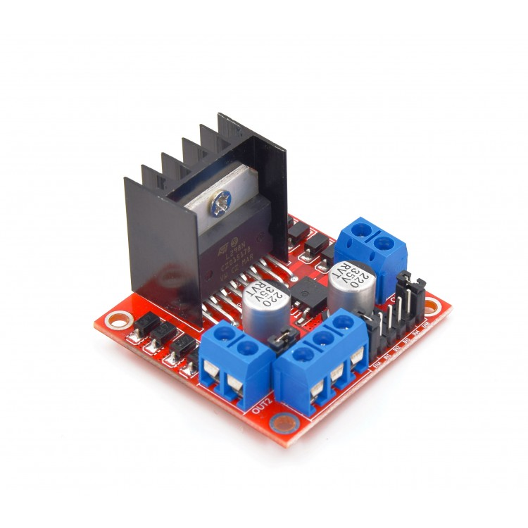

Figure 8 L298N Motor Controller

This L298N Motor Driver Module is a high power motor driver module for driving DC and Stepper Motors. This module consists of an L298 motor driver IC and a 78M05 5V regulator. L298N Module can control up to 4 DC motors, or 2 DC motors with directional and speed control.

**L298N Module Pin Configuration:**

|  |  |
| --- | --- |
| **Pin Name** | **Description** |
| IN1 & IN2 | Motor A input pins. Used to control the spinning direction of Motor A |
| IN3 & IN4 | Motor B input pins. Used to control the spinning direction of Motor B |
| ENA | Enables PWM signal for Motor A |
| ENB | Enables PWM signal for Motor B |
| OUT1 & OUT2 | Output pins of Motor A |
| OUT3 & OUT4 | Output pins of Motor B |
| 12V | 12V input from DC power Source |
| 5V | Supplies power for the switching logic circuitry inside L298N IC |
| GND | Ground pin |

**L298 Module Features & Specifications:**

* Driver Chip: Double H Bridge L298N
* Motor Supply Voltage (Maximum): 46V
* Motor Supply Current (Maximum): 2A
* Logic Voltage: 5V
* Driver Voltage: 5-35V/2A
* Logical Current:0-36mA
* Maximum Power : 25W
* Current Sense for each motor
* Heatsink for better performance
* Power-On LED indicator

1. **CODE FOR ARDUINO**

**CODE**

#include<Wire.h>  
const int MPU = 0x68;//12C address f the MPU-6050  
int16_t AcX, AcY,AcZ,Tmp,GyX, GyY,GyZ;  
  
//pwm  
  
int sensorValue=0;  //variable to store the value comming from the sensor  
  
int sensorValue2 =0;  
  
int val=0;  
  
int val2=0;  
  
int v;  
  
//pwm ends  
  
  
void setup()  
{  
  //controller pins define  
  pinMode(9,OUTPUT);  
  pinMode(10,OUTPUT);  
  pinMode(11,OUTPUT);  
  pinMode(6,OUTPUT);  
  //define ends*/  
  
  Wire.begin();  
   
  Wire.beginTransmission(MPU);  
   
  Wire.write(0x6B); //PWR_MGMT_1 register  
   
  Wire.write(0);  //set to zero (wakes up the MPU-6050)  
   
  Wire.endTransmission(true);  
  
  
  Serial.begin(9600);  
  
  
}  
void loop() {  
  Wire.beginTransmission(MPU);  
   
  Wire.write(0x3B); //starting with resistor 0X3B(ACCEL_XOUT_H)  
   
  Wire.endTransmission(false);  
   
  Wire.requestFrom(MPU,14,true);//request a total of 14 registers  
   
  AcX = Wire.read() << 8 | Wire,read(); // 0x3B (ACCEL_XOUT_H) & 0x3C  
  (ACCEL_XOUT_L)  
  
   AcY = Wire.read() << 8 | Wire,read(); // 0x3D (ACCEL_YOUT_H) & 0x3E  
  (ACCEL_YOUT_L)  
  
   AcZ = Wire.read() << 8 | Wire,read(); // 0x3F (ACCEL_ZOUT_H) & 0x340  
  (ACCEL_ZOUT_L)  
  
  Tmp=Wire.read()<<8|Wire.read();0x41 (TEMP_OUT_H)&0x42(TEMP_OUT_L)  
  
  GyX = Wire,read() << 8 | Wire.read(); //0x43 (GYRO_XOUT_H) & 0X44  
  (GYRO_XOUT_L)  
  
  GyY = Wire,read() << 8 | Wire.read(); //0x45 (GYRO_YOUT_H) & 0X46  
  (GYRO_YOUT_L)  
  
  GyZ = Wire,read() << 8 | Wire.read(); //0x47 (GYRO_ZOUT_H) & 0X48  
  (GYRO_ZOUT_L)  
  
  Serial.print("AcX=");Serial.print(AcX);  
  
  Serial.print("|AcY=");Serial.print(AcY);  
  
  Serial.print("|AcZ=");Serial.print(AcZ);  
  
  Serial.print("|Tmp=");Serial.print(Tmp/340.00+36.53);  
  
  Serial.print("|GyX=");Serial.print(GyX);  
  
  Serial.print("|GyY=");Serial.print(GyY);  
  
  Serial.print("|GyZ=");Serial.println(GyZ);  
  
  
  
  
  //pwm  
   
  sensorValue=AcX;  
   
  sensorValue2=AcY;  
   
  if(-900<AcY>-100)  
  
  {  
     
    if(AcX>600)  
     
    {  
      digitalWrite(9,LOW);  
  
  
      digitalWrite(11,LOW);  
       
      val=map(sensorValue,300,1700,0,175);  
       
      analogWrite(6,val);  
       
      analogWrite(10,val);  
       
    }  
  
  
    if(AcX<300)  
  
    {  
  
      digitalWrite(10,LOW);  
  
      digitalWrite(6,LOW);  
  
      val=map(sensorValue,300,-17000,0,175);  
  
      analogWrite(9,(2*val));  
  
      analogWrite(11,val);  
    }  
  }  
  {  
    if(AcY>450)  
  
    {  
  
      val2=map(sensorValue2,500,17000,0,150);  
       
      v =2*val2;  
       
      digitalWrite(10,LOW);  
       
      analogWrite(9,v);  
  
      analogWrite(6,v);  
       
      digitalWrite(11,LOW);  
       
    }  
  
    if(AcY<(-450))  
  
    {  
  
      val2=map(sensorValue2,-500,-17000,0,150);  
       
      analogWrite(10,val2);  
       
      digitalWrite(9,LOW);  
       
      analogWrite(6,LOW);  
       
      digitalWrite(11,LOW);  
  
      analogWrite(11,val2);  
       
    }  
  
    delay(100);  
  
}

**FUTURE SCOPE**

* Using of sensors based baking system.
* Installation of more sensors to get more efficient work.
* Using of composite material for the build-up.
* Making it fully automated.
* Advantages
* Become more productive: more work can be done by using the product versus walking.
* In-built battery charge indicator.
* Requires less space for riding, parking.
* Low operating costs: no need for gas as it is completely battery powered.
* Reduces fatigue caused by walking
* A clean, green, eco-friendly machine! (zero emission).
* Disadvantages:
* Slow, having a max speed of 12.5 mph
* Does not exactly say how far the Segway will go with riders of different masses.
* Heavy, weighing around 40-45kgs.
* Unlike bicycles, a malfunctioned Segway cannot be pedalled back home/garage.
* Applications:
* Our target is for college, school and office use where required longer distance to travel on footsteps.
* In workplaces, where most of the workers are aged, and have long routes to travel.
* For amusements parks, our Segway would be so simpler that even kids can drive safely.
* It would prove to be a better alternative for police cars.
* Also for personal use.

**CONCLUSION**

The basic aim of our construction is that to make such design which is cost effective and attractive. So our Segway consists of two rectangular boxes which at the middle has two slots in which 12V dc motors are kept and fixed in such a way that their shafts are out of the boxes to which a chain drive is attached, which further drives the wheels. On the upper part of the box the handle of the Segway is attached at the centre.

This project is implemented with an idea to find an effective solution to transportation problem. The main objective is to achieve space utilization and minimize the fuel consumption especially for commuting over shortest distance.